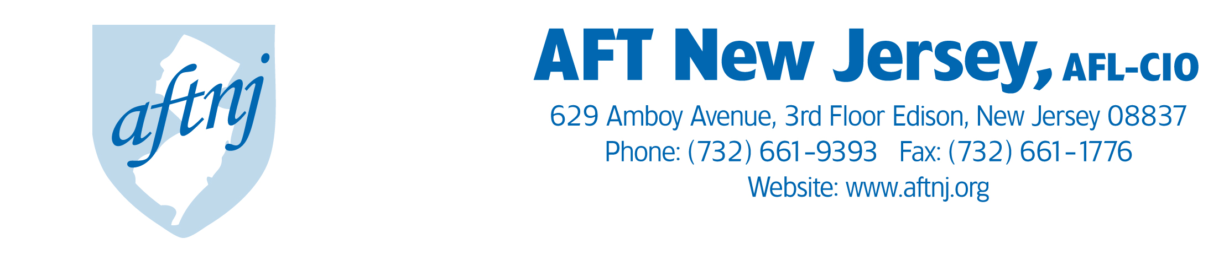

QSAC Testimony- 3/24/14
Good morning Senator Ruiz and the distinguished members of the Senate Education Committee and thank you for the invitation to testify before you today. My name is Donna Chiera and I am the president of AFT New Jersey, former president of the Perth Amboy AFT local, and a lifelong educator. I come before you today to discuss my experiences with the Quality Single Accountability Continuum, to point out where the system fails us as a state, and to identify new approaches to improve our districts and public education in New Jersey
QSAC asks districts to evaluate their compliance in five categories. Though streamlined from a survey with more than 300 indicators that were required when the system launched in 2007, the evaluation process is often time-consuming, labor-intensive, and in many cases, repetitive. While we strongly believe in a thorough accountability system for our school districts, QSAC can be intrusive. For instance, I served on the QSAC team in Perth Amboy and we submitted our financial information as part of our QSAC review in addition to our Abbott district audit, a Title I audit, and a County Superintendent audit. Complying with the requests from these entities takes time away from delivering a high quality education to our students and the demands on district time could be eased with improved communication between the requesting agencies. Additionally, there needs to be more distinction between the indicators and categories QSAC looks at. In Perth Amboy, we failed the Instruction category because our curriculum didn’t fully align with Common Core Standards. Ultimately that also led to the district failing the Governance category. Districts should not be penalized twice for one mistake.
QSAC forces districts to concentrate their efforts on compliance with the indicators on the assessment rather than identifying areas where districts can improve. QSAC doesn’t seriously measure student achievement or academic gains. An accountability system should provide districts with the support and resources to come up to compliance in areas where it does not currently meet the state standards. In these areas, the accountability system should mirror the supports institutionalized in TEACHNJ, New Jersey’s tenure reform law. If a teacher receives a poor evaluation, the teacher works with the district to diagnose their weaknesses and receives an improvement plan to bring their performance to the appropriate level. If QSAC is to be a true improvement tool and not just a compliance checklist, a similar support system should be instituted for struggling districts.
Requirements surrounding the state takeover districts have been ambiguous since QSAC was launched. While state control over three districts (Newark, Paterson, and Jersey City) predates QSAC, it still has become the method of returning operations to local control. However, the state Department of Education has inconsistently used this power to give districts authority back- while Jersey City has regained some governance, Newark remains under state control despite passing four of the five QSAC categories as recently as 2011 as the state Department of Education did not feel that the district demonstrated “sustained progress”. This shows a lack of respect to the local district and community, whose input is often ignored in takeover districts. The Legislature should demonstrate leadership in establishing a process in which an accountability system is used to permanently transition takeover districts to local control. This system should prioritize stability and include safeguards to prevent control bouncing back and forth between the state and local district based on if a district passes a category or not.
Moving forward, we would like to see QSAC or any accountability system in New Jersey put more of an emphasis on community input. The system should solicit the opinion of the community, including parents, businesses, community organizations, or any person or group with an interest in their local schools’ performance. This is especially true in the state takeover districts, where too often the state appointed superintendents and district leadership do not solicit community input or engage in meaningful dialogue with local stakeholders. Additionally, our accountability systems should diagnose which districts need resources and ensure that these supports flow toward districts and schools in need. QSAC could help identify these districts in need so that the Legislature and Department of Education can provide them with adequate financial support and educational assistance. The remedies for districts found wanting in certain categories should not be punitive, should not lead to privatization or outsourcing of our public education system, and should be student-centered with the clear objective of improving our schools.
Thank you for inviting me to testify before your committee today. The goals of our state’s district accountability system need to be clear. Is the goal simply compliance or do we want to identify a roadmap to improve public education? AFT New Jersey is willing and able to assist this body in helping New Jersey develop an accountability system that can lead to real gains for students in our state.

American Federation of Teachers New Jersey (AFTNJ), AFL-CIO
www.aftnj.org | www.facebook.com/aftnj | twitter @aftnj

Labor produced

